**DAILY ONLINE ACTIVITIES SUMMARY**

|  |  |  |  |  |  |  |  |
| --- | --- | --- | --- | --- | --- | --- | --- |
| **Date:** | **05/06/2020** | | | | **Name:** | **Churashma** | |
| **Sem & Sec** | **4th SEM 'A' Section** | | | | **USN:** | **4AL18CS019** | |
| **Online Test Summary** | | | | | | | |
| **Subject** | | **No test** | | | | | |
| **Max. Marks** | | **-** | | **Score** | | **-** | |
| **Certification Course Summary** | | | | | | | |
| **Course** | **Introduction to cyber security** | | | | | | |
| **Certificate Provider** | | | **greatlearning academy** | **Duration** | | | **7.5 hours** |
| **Coding Challenges** | | | | | | | |
| **Problem statement 1: Write a Java Program to find the duplicate characters in a string.** | | | | | | | |
| **Status: completed** | | | | | | | |
| **Uploaded the report in Github** | | | | **yes** | | | |
| **If yes Repository name** | | | | **https://github.com/Churashma/Lockdown-coding** | | | |
| **Uploaded the report in slack** | | | | **yes** | | | |

**ONLINE TEST DETAILS:** No test

**CERTIFICATION COURSE DETAILS:** Today I studied about Introduction to cryptography and secure system design. The art and science of concealing the messages to introduce secrecy in information security is recognized as cryptography. The process of disguising a message in such a way as to hide its substance is encryption. An encrypted message is ciphertext. The process of turning ciphertext back into plaintext is decryption. Security risks occur when people take deliberate actions to harm or damage your organization. Security system design is the process that allows clients to control the access that people have to their organizations assets with a coordinated and prioritized approach to asset protection by design.

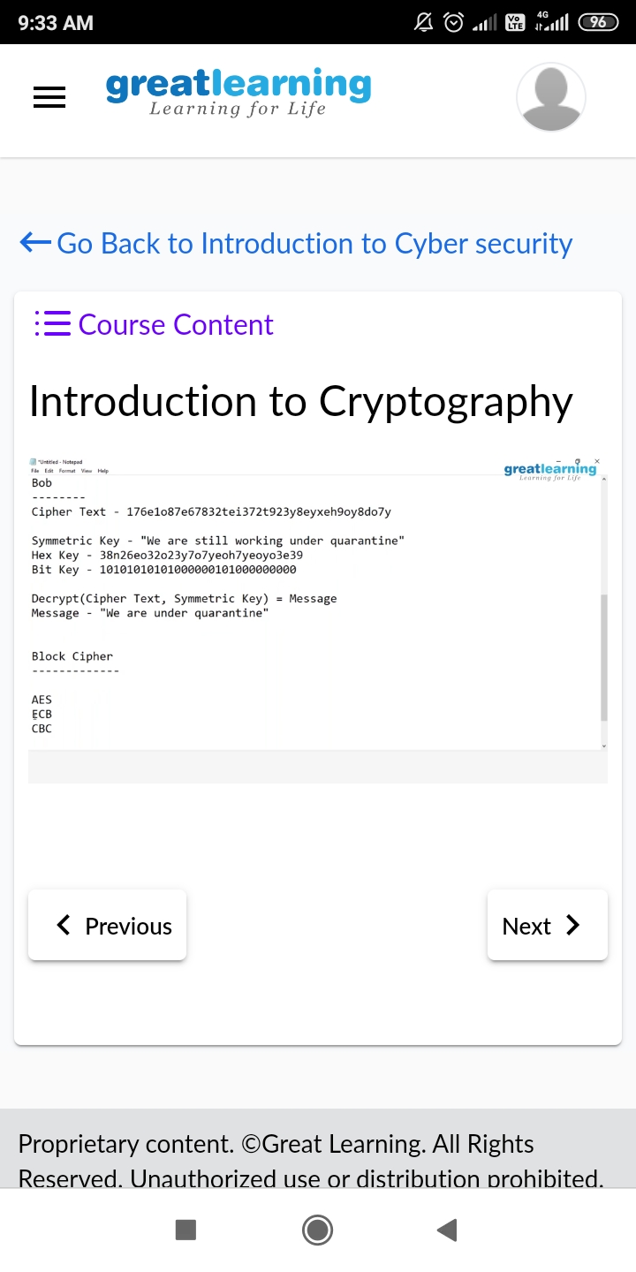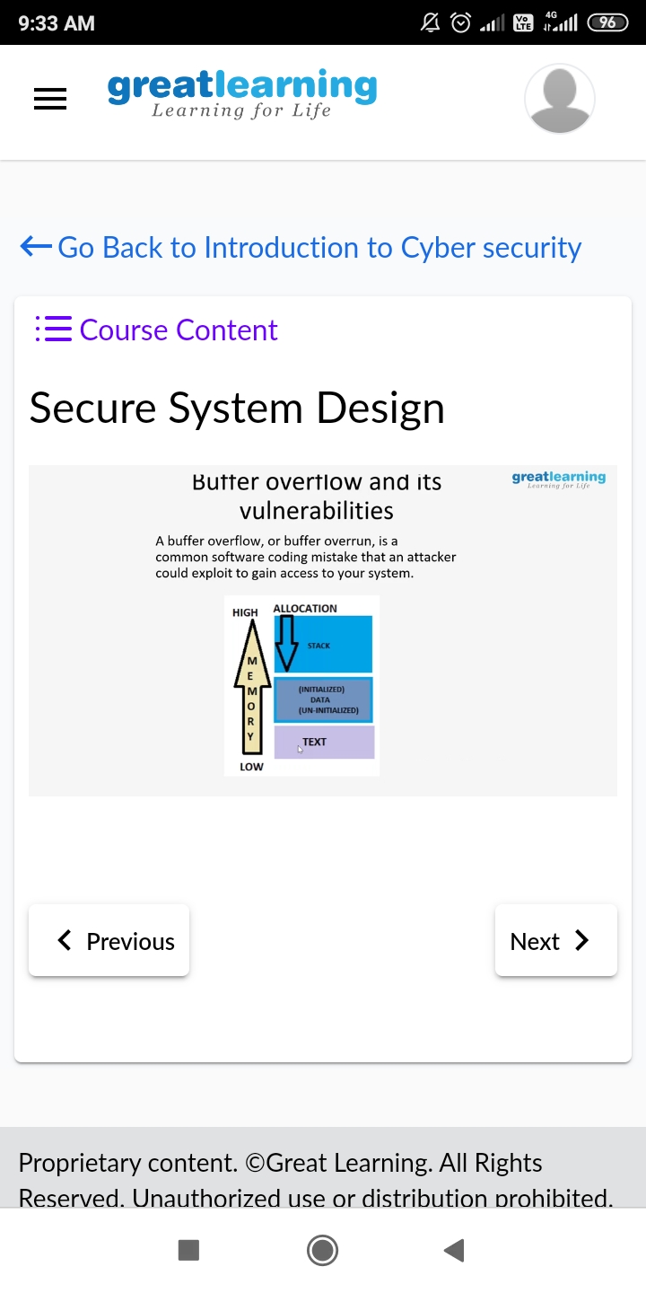

**CODING CHALLENGES DETAILS**:

**Problem statement 1:** Write a Java Program to find the duplicate characters in a string.

